**Cloud Computing Individual Assignment 3- Gianni Pessotto (13199219)**

The following proposed diagrams create an architectures that will enable the business in question to be able to provide a sustainable amount of cloud computing resources with the ability to scale down or up, depending on the situation as well as being able to purchase additional cloud resources should the needs exceed what the business is capable of providing to consumers.

As a result of the businesses needs, a system utilising AWS and Elastic Beanstalk to seamlessly implement a single application that can manage itself as well as require simple configurations and a single deployment, as opposed to implementing each individual component which requires their own configuration and deployment.

The following components will be necessary to construct an AWS system of this nature and ability.

**Key Components-**

* Elastic Beanstalk
* Amazon EC2
* AMIs
* Security Groups
* A Load Balancer
* Auto Scaling with Instances
* Multi availability zones
* Virtual Private Cloud
* Custom Key Pair
* Email Notification

**Assumptions-**

In creating this report, numerous assumptions about the context and use of the AWS architecture were created to fulfill the needs presented and other possible needs that may arise. For example, it was not specified what exactly the business provides or who it provides for. Thus it was natural to assume it may serve businesses and individuals alike. Another assumption was that the businesses capacity to provide resources is unknown and so other resource providers may be necessary to aid in ensuring the scale up or down process went smoothly and left no holes in supply.

Therefore, two diagrams were created. One to show the size and general consensus of operations as well as a diagram to specifically show the interactions of detailed AWS services active within the system provided.

**Diagram 1:**

Diagram 1 is the general diagram illustrating the operations of the business in terms of provision and management of general cloud resource use. The Business Owner receives valuable data and makes the business decisions. The administrator is in command of scaling up or down processes as well as resource provision. The customer, whether a business or an individual, has been streamlined to follow the same process to ensure smoother operations. Numerous backup storages exist as well as the ability to purchase more resources from an external provider.

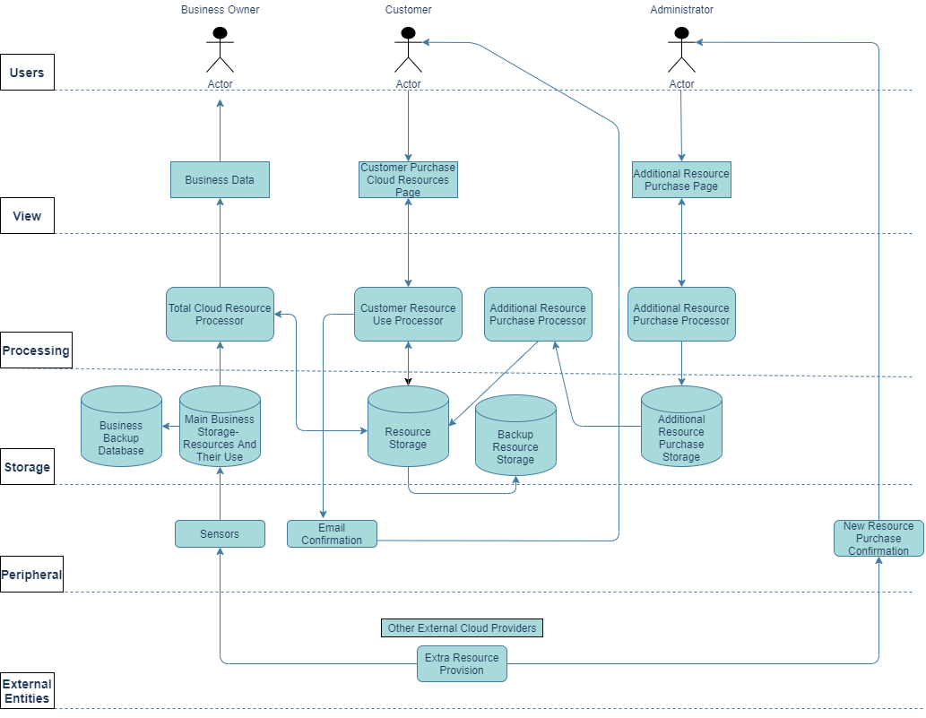

**DIagram 2:**

